**Enzymes page #___________**

**What are enzymes:**

* Made of ____________________.
* Biological __________________.
  + A _______________ is a substance that ____________ ____ a chemical ____________, without itself being chemically _________________.
  + ______________ amount needed.

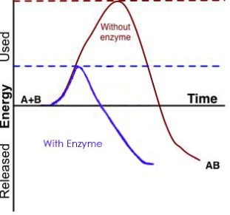**What do enzymes do?**

* Enzymes ____________ the __________________ ____________ and _______________ __________ the reaction.
  + Activation energy: __________________________________

__________________________________________________

__________________________________________________

__________________________________________________

**Lock and Key model**

* Active site: Where the ______________ ___________ to the ________________.
* 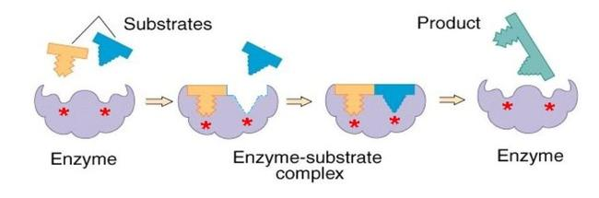Substrate: substance _______________ with the __________________.

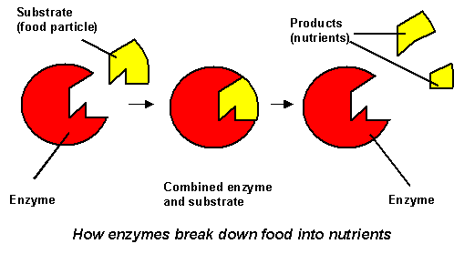

**Factors that affect enzymes:**

* Every enzyme has _____________ _______________ under which it will work

1. Temperature: Each ____________ has its _____ ___________ _______ where it __________ .
   * Temperature much ____________ than ideal can ____________ the enzyme.
   * DENATURE: breaks ______________ ________________ and changes the _________________ of the __________________ so its ______________ __________ ____________.
2. pH
   * each ______________ has a _____________ pH where it _____________ ___________.
   * Too ___________ or too _________ and it does _____________ _____________ as well or _________________ _________________ entirely.
3. Concentration
   * The ______________ ________________ is available, the _________________ the __________________ , until all the _________________ has an ________________.

